PRACTICAL - 07
Name:M.Akhila
Rollno: 2520030511

Section: 8

EXPERIMENT – Memory Address Space and /proc/<PID>/maps Aim:
To write a C program that prints the addresses of code, global, static, heap, and stack variables, and analyse the Linux process
address-space layout using /proc/<PID>/maps.

Objective:
- To understand the memory layout of a Linux process.
- To identify code, global, static, heap, and stack regions.
- To observe virtual memory mappings using /proc/<PID>/maps.
- To understand how Linux organizes memory for a running process.

Problem Statement:
Write a C program to display the addresses of different types of variables and use /proc/<PID>/maps to study the virtual memory organization of the running process.

Theory:
A Linux process has its own virtual address space. Important regions include:

Memory Segment | Purpose
Code/Text | Contains program instructions
Global/Data | Contains initialized global variables
BSS | Contains uninitialized global/static variables
Heap | Used for dynamically allocated memory
Stack | Stores local variables and function information
Shared Libraries | Libraries mapped into the process address space
The /proc/<PID>/maps file shows the virtual memory regions currently mapped into a process.
Example:
55a1...-55a1... r-xp ... /program
55a1...-55a1... rw-p ... /program
7f2...-7f2... r-xp ... /libc.so.6
7ffd...-7ffd... rw-p ... [stack] Here:
- r = Read
- w = Write
- x = Execute
- p = Private mapping

Algorithm:
- Declare a global variable.
- Declare a static variable.
- Create a local stack variable.
- Create a function to represent the code segment.

- Allocate memory dynamically using malloc().
- Print the addresses of all variables.
- Print the process PID.
- Keep the program running.
- Open /proc/<PID>/maps from another terminal.
- Analyse the virtual memory mappings.
- identify the stack, heap, program, and shared-library regions.
C Program: #include <stdio.h> #include <stdlib.h> #include <unistd.h> int global_var = 10;
static int static_var = 20; void code_function()
{
printf("Code address : %p\n", (void *)code_function);
}int main()
{
int stack_var = 30; int *heap_var;
heap_var = (int *)malloc(sizeof(int)); if (heap_var == NULL)
{
printf("Memory allocation failed\n"); return 1;

}
*heap_var = 40;
printf("Linux Process Memory Layout\n"); printf(" \n");
printf("PID : %d\n", getpid());
printf("Code address : %p\n", (void *)code_function); printf("Global address : %p\n", (void *)&global_var); printf("Static address : %p\n", (void *)&static_var); printf("Heap address : %p\n", (void *)heap_var); printf("Stack address : %p\n", (void *)&stack_var); printf("\nProcess is running...\n");
printf("Use another terminal to check /proc/%d/maps\n", getpid()); while (1)
{
sleep(10);
} free(heap_var); return 0;
}

OUTPUT:

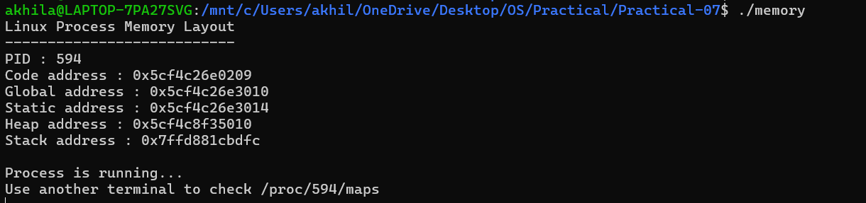

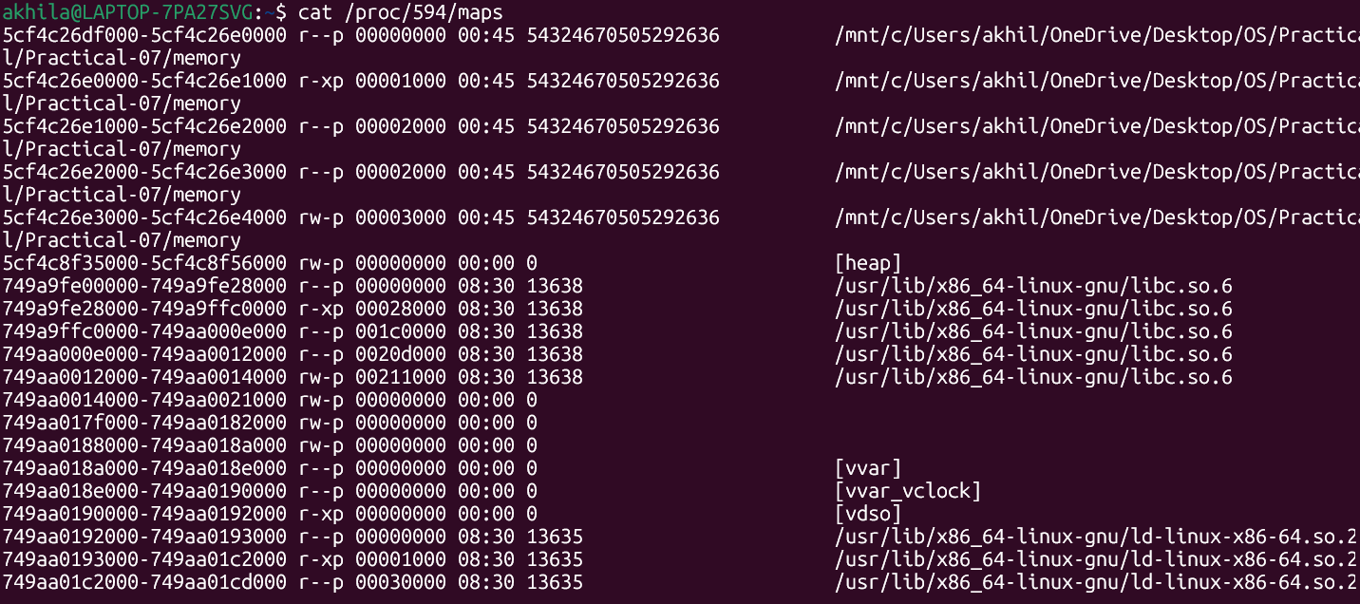
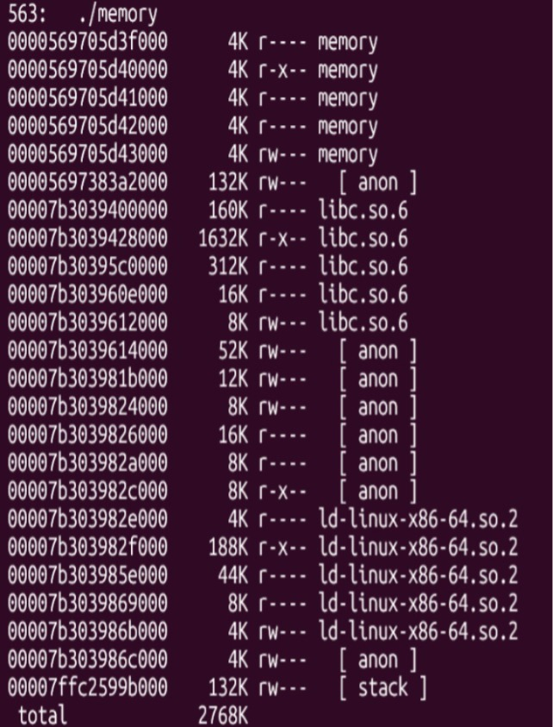

Observation:
- The program displayed different virtual addresses for code, global, static, heap, and stack variables.
- The heap and stack appeared as separate regions in
/proc/PID/maps.
- The executable and shared libraries were also mapped into the process address space.
- /proc/PID/maps provided information about the permissions and ranges of each virtual memory mapping.

Result:
The C program was successfully implemented to display addresses of the code, global, static, heap, and stack regions. The
/proc/<PID>/maps file was used to analyse the virtual memory organization of the running process.

Conclusion:
The experiment demonstrated how Linux organizes a process into different virtual memory regions. The memory addresses printed by the program, together with /proc/<PID>/maps, helped identify the code, data, heap, stack, and shared-library mappings.

